Having a million conversations without getting distracted.

**Introduction**

Have you ever wondered if privacy is important?

To keep something private means being able to selectively withhold the distribution of information about it. The world we live in is one in which privacy is being phased out.

It appears we do not have a real choice when it comes to how much of our life we share with the world. Our personal information and traces of our activities are available to whoever is interested in them. But we do not live in an oppressive Orwellian society or a blissfully ignorant ‘Huxleyesque’ dystopia. We can talk to each other – we can talk with everyone.

The technologies we possess present us with an unprecedented opportunity to do things together, in scales previously unimagined.

While some might choose to resist the increased visibility of experiences previously reserved for individuals, I am interested in what happens when these are shared. This is why I decided to release my dissertation into the world before it is formally completed - to involve others in forming it.

For the purpose of this work ‘crowds’ are groups made of individuals, which have some form of real time (instantly or near-instantly transferrable) communication between all of them. Until recently that implied that they needed to be in relatively close geographical proximity. My work deals with crowds and how the individual should regard them

Our information is constantly being released into a crowd; today this happens even without us being conscious of that fact. By analysing our output and then re-releasing it we are helping to better the crowd. Why should we not, if we cannot avoid being a part of it anyway? It is like a single cell within a body that does what ever it can to help and improve the well being of the entire body. We may not always have useful information, but I want to show how by doing what we can, sharing our insights, we strengthen crowds to which we belong. All the examples of participations you will read about illustrate the actions of self-interested individuals. I intend to show how selfishness, alongside other sentiments, is essential for a successful collaboration. Beyond this I want to share with you the feeling that making something together is a beautiful thing.

**Research Report**

The first thing that attracted me to the subject of crowds was a Ted talk by Alexis Ohanian[1]. In this presentation Ohanian described how the users of his co-created website, reddit, affected the results of Greenpeace's poll to name a whale (the name they voted for was ‘Mr splashy pants’). The reason for the poll was part of an effort to interfere with the Japanese government’s plans to hunt Humpback whales for research purposes[2]. The redditors (users of reddit) debatably cared about this and instead saw this as a game where the goal was to make the organization do something they did not mean to do. The other names offered by Greenpeace were ethereal sea gods names, and at first the poll’s deadline was extended so that the reddit disturbance would blow away. Ultimately this resulted in enough media coverage that made the Japanese government change its decision[3] (and Splashy won the competition).

The direct result of listening to this talk was that I began spending a lot of time browsing reddit.

What is reddit?

According to the site’s Frequently Asked Question[4] Page:

‘reddit is a source for what's new and popular on the web.  
Users like you provide all of the content and decide, through voting, what's good and what's junk.  
Links that receive community approval bubble up towards #1, so the front page is constantly in motion and (hopefully) filled with fresh, interesting links.’

Using it felt like I was making a difference and I became attracted to the thought that I could, one day, find myself instrumental in positively affecting and promoting causes I deem worthy; but doing so without too much effort or commitment on my side.

My first impression of such an event unfolding in real time was Hurricane Sandy and the way individuals offered to help in any way they could[5]. Examples include people offering to come and help or letting strangers know they had electricity so they could charge their electrical devices. By ‘upvoting’ comments of people who volunteered help I increased the chances those who needed assistance seeing these offers. I may have been in another country and had no practical way of helping anyone directly affected, however, I felt I was helping in a real way.

The thing that baffled me the most was how could these tools for communicating on such a grand scale develop without me noticing every step of the way? I find the ability to use other people to learn new things a much more attractive proposition than using a search engine. And I imagine that many can identify with that feeling. I discovered what I believe to be the answer to this in Malcolm Gladwell’s book ‘The Tipping Point’, where he explains that more often than not, great change occurs near instantly when a critical point of saturation or exposure occurs. He demonstrated this effect with the example of water turning to ice:

‘Almost nothing had changed, in other words, yet and this was the amazing thing -everything had changed. Rain had become something entirely different. Snow![6] (p.13)’

Next I read ‘The Wisdom of Crowds’ by James Surowiecki. In it he tries to make sense of what makes large groups potentially superior to the individuals within it, making the case for group intelligence. The author identified Diversity of [opinion](http://en.wikipedia.org/wiki/Opinion), Independence, Decentralization and Aggregation as the four characteristics essential for the ‘wise crowd’ (Surowiecki, 2005).

Suroweicki mentions Gustave Le Bon, a 19th century thinker who famously wrote ‘The Crowd: A Study of the Popular Mind’. In it Le Bon proposed that crowds are to be viewed as singular units, rather than many separate individuals. Unlike Suroweicki he proposed that crowds have only the Intelligence and intellect shared between all of its members. In other words crowds act as a primitive human being would, compelled by instincts and prone to irrational senseless acts. He points out that individuals in a crowd do things they would never seriously contemplate on their own. Le Bon attributed these actions to several causes, amongst them a sense of invincibility lent to an individual by belonging to the crowd. His argument describes the individuals as hypnotized and the crowd the hypnotist.

A lot of my research consisted of browsing reddit. In reflection I *was* hypnotizedby the sheer volume of things I found interesting, the ease in which I could contribute to conversations, create content and later the possibility of getting attention.

As a graphic design student, I became increasingly interested in non-designers’ visual content generation. I decided to explore that and got very much into web ‘memes’. To understand the term in context of the internet, it makes sense to describe it as the online community does. Owing to it’s user moderated content (the most popular entry is at the top of the list) urbandictionary.com does a fair job explaining what a ‘meme’ is:

1.meme[7]

(noun)

1 : an idea, belief or belief system, or pattern of behavior that spreads throughout a culture either vertically by cultural inheritance (as by parents to children) or horizontally by cultural acquisition (as by peers, information media, and entertainment media)

2 : a pervasive thought or thought pattern that replicates itself via cultural means; a parasitic code, a virus of the mind especially contagious to children and the impressionable

…

5 : an internet information generator, especially of random or contentless information

…

The specific kind of meme I studied is the **image macro**: ‘the most common type of image macro is a photograph with large text superimposed in [Impact](http://en.wikipedia.org/wiki/Impact_(typeface)) font, using all upper case letters and coloured white with a thick black outline. Exaggerated, intentional spelling errors are also used frequently for humorous effect.’[8]

Some examples:

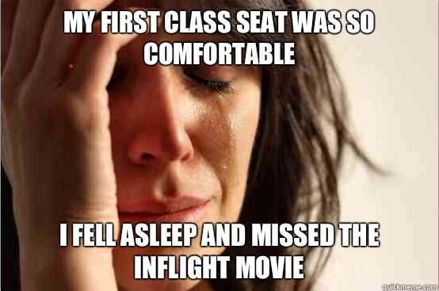

(http://www.quickmeme.com/img/ad/ad043e6650478a0035745dcc3362d0a50297acf66b6b8086f1bfb6cb60309905.jpg)

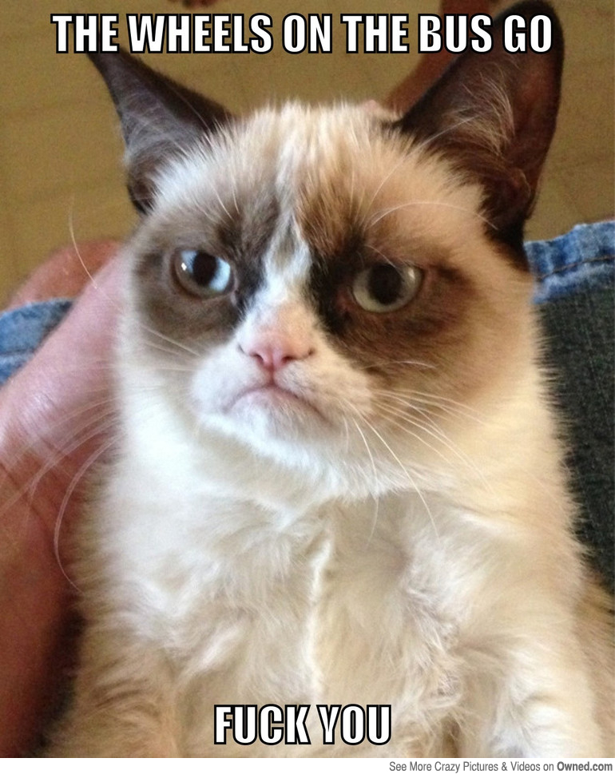

(http://i.qkme.me/3ru52b.jpg)

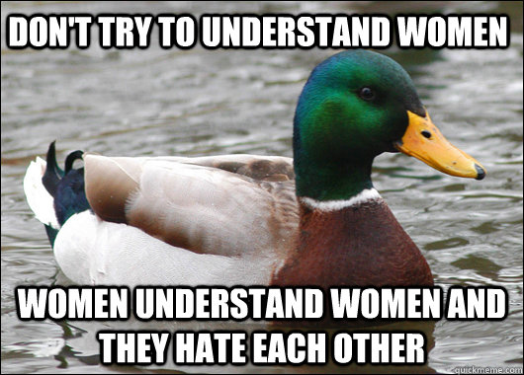

(<http://www.humormeetscomics.com/wp-content/uploads/2013/01/women.jpg>)

Albeit very amusing and engaging spending hours going through these images, I did not feel like I learned anything or gained serious knowledge. It was then that a friend recommended I read ‘Here Comes Everybody’ by Clay Shirkey.

Shirkey explains how the Internet and its modes of communication function. His main point, which was enlightening at this stage of my research, is that ‘more is different’. The sentiment, taken from the world of physics, expresses the notion that it would be impossible to tell how an individual will behave in a group when they have only been observed in isolation[9]. Similarly, observing the conduct of groups numbering in the dozens does not provide insight into the behaviour of groups numbering in the thousands. This is why we struggle to understand how a large crowd is affected by our actions.

In the beginning of this report, I claim that crowds are people who are linked together via means of communication. Shirkey describes the connection between communication and crowds by linking amateur content generation and social relationships[10]. Finding people (who we share an interest with) is very easy nowadays. If something we have to say is important to enough people, then our system of social connections will see it distributed like a ripple in a pond. On the other hand, that ‘wise crowd’ will filter out any comments which only few have any interest in.

Shirkey’s final point is that the political value of the increased ease of self-expression is unarguably positive[11]. It is hard to decide if being able to share videos of unfolding disasters from ground zero and having tools such as Wikipedia benefits us more than terrorists hacking activity puts us in danger. However, it is widely accepted that freedom is something we desire for our society, so having the ability to freely express ourselves stands positive.

Why is being connected to so many others beneficial to us? In his book, The Black Swan, Nassim Nicholas Taleb proposes that what we do not know is much more important than what we do know. ‘Think of the terrorist attack of September 11, 2001: had the risk been reasonably conceivable on September 10, it would not have happened’[12]. Taleb tries to make the case for how increased availability of data is detrimental to our ability to make the right choices[13]. This brings us back to Suroweicki’s proposal – if there is too much information for one person to make sense of, let the crowd have a go. According to Shirkey, we have the technology.

Our society has changed drastically over a very short period. We now possess better and faster modes of communication. The improved communication makes us capable of things we have yet to realise.

With this understanding I searched for graphic design works that make use of social and crowd based resources. As a designer I am interested in projects that aim to draw creativity out of participants, but not chiefly for financial gain. The examples I found range from touching tribute pieces like The Johnny Cash Project[14] to a basic free-for-all 20x20pixel canvas titled ‘The smaller Picture’[15]. They vary in how much input participants have over their contribution. In some cases, like ‘Listen to Wikipedia[16]’ – an audio visual representation of live changes to Wikipedia, information is used without the knowledge of the collaborators.

My search eventually led me to the following three crowd sourced creative endeavors:

* Star Wars Uncut

A fan made, remake of the original popular film

* SwarmSketch

An online canvas where, each week, users are invited to collaboratively draw a phrase.

* Selfless Portraits

In this website, users are invited to draw Facebook profile pictures of stranger, and in return have their own photos drawn by someone else.

I will describe and analyse these projects, In order to come up with an answer to my research question, ‘How to deal with the crowd?’.

**Star Wars uncut**

Star Wars uncut is a project in which many fans (otherwise complete strangers) of the film cocreated a full remake of the 2004 ‘special edition release’ (Wikipedia). The project, conceived by Casey Pugh who, in July 2009 set up the website which allowed fans to take part.

The website featured in the original film cut into 473, 15 seconds segments. Would-be participants had to submit original remakes for those segments. When the process finished Pugh compiled the selected scenes and realeased a full length, fan made movie.

The film is available in its final form online for free. The submissions that did not make it to the final version are not accessible as far as I can tell.

The next Star Wars film in the series 'The Empire Strikes Back is currently in production. The scenes submitted towards the sequel appeared to be available to watch and vote on at the moment. It is not clear whether voting for them makes any difference at this stage.

The official website features an alphabetical list of all the contributors as does the edited films' end credits. The names are often clearly pseudo names, and there is no further information about them.The site credits The administrative team in charge of the project (including Pugh), and there are direct links to their websites/twitter accounts etc.

The film itself shows an amazing range of different approaches. The visual styles of the scenes range from polished computer animation to well executed Lego stop motion animation. It also features home-made clips of children playing in corridors wearing dressing gowns and costumes. It is plain to see how the film touched the lives of so many people in varied ways (some of the scenes even feature some non-English speakers, judging by the accents).

One of the most endearing facts about the film is that it editors are not a select group but are, in fact, more numerous than the sum of the art contributors and the admin staff put together. Judging the way the next instalment is progressing online, anyone could (after logging in) comment and vote on the scenes they watched. All of the individual scenes in the film are subject to collective scrutiny, fifteen seconds at a time. Each such scene is voted as the best by a highly inclusive process. It matters little if a person dislikes one scene. When the edited version of the film is complete, the result is harmonious. I am not an avid fan of Star Wars, yet I feel as if Star Wars Uncut has a message that excites me. It is fun to watch because it suggests that by exerting little effort, we can be part of something impressive and complex.

The project's website has a list of rules for those who wish to participate: The project's website has a list of rules for those which to participate:

**In order to keep Star Wars Uncut awesome and ready for the big screen, we request that you make your scene...**

**Original**

You may only upload videos you yourself have made. This is your time to be creative! Do not include 3rd party brands or content. We all love [insert product here], but we don't want to get sued over it.

**In 30 Days.**

After accepting your scene, you have 30 days (720 hours) to complete and upload it.

**Without the original audio**

This includes the original Star Wars audio track...part of the fun is making the audio yourself! We will be adding in the soundtrack in the final cut.

**OK for the kids.**

Please, no sexually explicit videos or derogatory language.

**HD**

Try to shoot and upload your video in the highest quality possible. 16:9 format is preferred.

**Precise**

Each scene is 15 seconds, so let's try to keep it exact. Going over or under a few seconds is fine. Make sure the beginning and end of your scene matches up closely to the original. That way, the final piece will be smoother than Jabba's backside.

**FUN!**

This is your moment in the Star Wars sun. This project comes from the fans and will be as great as our collective minds create it. Pull out all the bells and whistles and probe droids.

**Remember, if you break any of these guidelines your scene will not be considered in the final cut.**

The penalty for breaking the rules is that your hard work will amount to nothing. The fact that most of these are guidelines to Broads to break (see **FUN!**), Shows that there is very little potential contributor cannot really do. It is assigned that the creators are not expecting to run into trouble, and that the average contributor wants to be a part of the project enough that he probably does not need to be reminded. The credential of being a part of the final production is a self-interested motivation. And it fuels all parts of this project.

As previously mentioned, there is a disappointing little left to link the original Star Wars uncut contributions to their makers. The new instalment seems different in that respect. Each scene is linked to by name to the creator's profile on the website. And many contributors have their photo representing them. I can comment on their scene publicly but not to get in touch with one person in particular. It is also not linked to any external social services such as Twitter or Facebook.

**Swarm sketch**

In 2005 Peter Edman of Canberra University, Australia initiated Swarmsketch.com. Swarmsketch is a project that aims to produce continuous stream of sketches drawn by crowds of strangers. The project is still remains in its original format. The format is very minimal the canvas is a square 450 x 450 pixel; all the lines added are in shades of grey.

Every week a random popular search term is selected to act as the title for a sketch. Anyone can contribute to the current sketch with no need to register. The contribution allotted to each user is of both creator and moderator – each time you visit the site you may draw into the canvas as many of 100 black pixels. You may then change the opacity of your line. After you do this you will be presented with the opportunity to change the opacity's of 50 other lines entered prior to your contribution. You do not however, have an absolute power over lines did not author. The final capacity of any pixel is determined by the average ‘vote’ on that line. The application is that it is hard for any individual to affect any serious change to any sketch once enough contributions are made. If more than 1000 lines are drawn the topic is changed and a new sketch begins.

Once a sketch is finished (after a week all 1000 contributions) access to it is limited to statistics such as total lines drawn, total opacity votes etc. And visitors of the site can watch timelapse version, which shows an animated version of the progression of the sketch.

It appears that all sketches are logged since 9 September 2005. Presumably do to the minimal criteria of participation (you must have Flash player enabled) there is no way to identify who contributed what. In the box titled ‘line information’ there is a location signature (which frequently states ‘unknown’) date stamp and the time of contribution. The Website does not feature any ways to comment on sketches.

The kind of creativity Swarmsketch gets out of participants cannot give us a clue as to the individual contributor’s personality. The format is extremely limiting of personalisation, and its mission is to show the masses collective effort. So it may be appropriate that no clear personal and individual signatures are permitted. The website makes the contribution of our line far easier than the subsequent moderating of existing ones. The moderation is limited to 50 lines and those at chosen at random. Therefore the appearance of a final sketch can be argued to be very genuine. Thus the similarity of the crowd is effectively captured. In other words, no one is capable of shaping the outcome the more participants there are. Moreover, even in the early stages the user has an extremely limited creative capability the more interaction sketch sees, the truer it represents the crowd. It can even be argued that if no one contributes that a reflection on how *not interested* the crowd is. Clay Shirkey said that website like these, whose accumulated content is dependent on willing participation (Wikipedia in his case), depend on people who even for the briefest of moments genuinely care about what they do[17]. Unlike the case of a wiki, Swarmsketch does not provide an invaluable service to its users. To protect itself from vandalism there needs to be a limit to an individual's power to edit.

When you draw a line in swarmsketch, its opacity is set to 100% (or black if you prefer). Whether you are the first to contribute to a sketch or a late contributor, it is fair to assume you will not feel incredibly involved in it, as it stands nothing to gain or to lose beyond the mere fact of your contribution and the time it takes to do so. You are not connected to any other past contributor, so it's unlikely you care about their lines. The result is that, at least to me, participating feels like a novel act – when you draw a line you leave a mark. But taking the time to moderate other lines feels pointless unless I am specifically in the mood. Even if I am inclined to participate what qualifies me to decide about others' work? It is the crowds effort, so I am only changing opacity based on whimsical intuition. Assuming others are mostly like me, and I cannot think of reasons they should be different, then the result is built on genuine acts – no one has or can act effectively on ulterior motives. Despite having means to moderate a sketch, individuals possess little if any insight regarding the final outcome of the work. Only the collective can know what it wants to do, and participants instrument of communicating with each other are so limited which makes for a very dumb collective. No wonder then that you of the sketches make any sense.

No official rules are in place; it would appear that the highly limiting nature of the project takes care of any ‘offenders’. It's basic user interface and interactivity wards of any serious attempts to mess with or ‘hijack’ a sketch.

The one limitation is technical; you must have Flash player, which means you need to have a flash enabled device.

All users leave fleeting impressions on Swarmsketch. If a sketch is fairly far along in its progression and you vandalise it by drawing a small line across it, the next person may reduce its opacity and nullify your input. The website does not record your personal information in anyway obvious, so not even you can confidently track your contribution. But it is important to remember that it was made eight years ago, before relied so heavily on web-based social tools. I think it is safe to assume that where it made today, a social element with even a basic sharing element would exist here. As it is, using Swarmsketch alone will not reflect on you in any foreseeable way. But its internal mechanism illustrates that it is preferable to work with the crowd and not against it.

**Selfless portraits**

Most people I know have a Facebook account. Even those among them who barely use the service have a profile picture and the quest for decent profile picture the truly represents the user right now is arguably never over. It was (notably) through Facebook that I came across the next case study. A friend of mine posted a link to it – it was not an advert with the comment ‘This is a really cool project, check it out!’.

‘Selfless Portraits’ accuses the chance to have a profile pictures drawn by strangers (other Facebook users) and to draw strangers’ profile pictures in return.

Ivan Cash and Jeff Greenspan created the site in partnership with the development team ‘Rally Interactive’[18] and launched it officially in February 2013[19].

Once you log into the service, which is a simple matter, you are requested to choose a photo from your existing profile pictures album. Your chosen photograph or be given to a stranger to draw and once that is done you immediately receive a stranger’s photo.

Once given to you you have 48 hours to reduce a drawn version of your allotted random profile picture. Your own photo will only be sent to someone else after you have completed drawing.

A regular Selfless Portraits user has access to the portraits he has drawn and to those of his others have drawn. It is possible to view the gallery of all the contributions made to date, which is consistently updated. The creators have also added an option to contact those you have had direct interaction with (i.e. those who drew you and those you have drawn). When it comes to portraits were not a part of processing, the interaction is limited to ‘liking’ them on Facebook and to sharing using various social tools (Pinterest and Twitter). Hovering over any portrait in the gallery reveals the owner’s name and in most cases their country of origin. Underneath that information, the details of the artists are also shared.

Browsing through the gallery page reveals the different approaches participants have to the project. I have looked through the gallery and I can identify at least four general kinds of portraits that are submitted in answer to the ‘brief’:

1. Scanned real-life drawings
2. Computer-generated illustrations
3. Digitally manipulated photographs
4. Images which bare no visual resemblance to the original photograph

**Scan real-life drawings[20]**

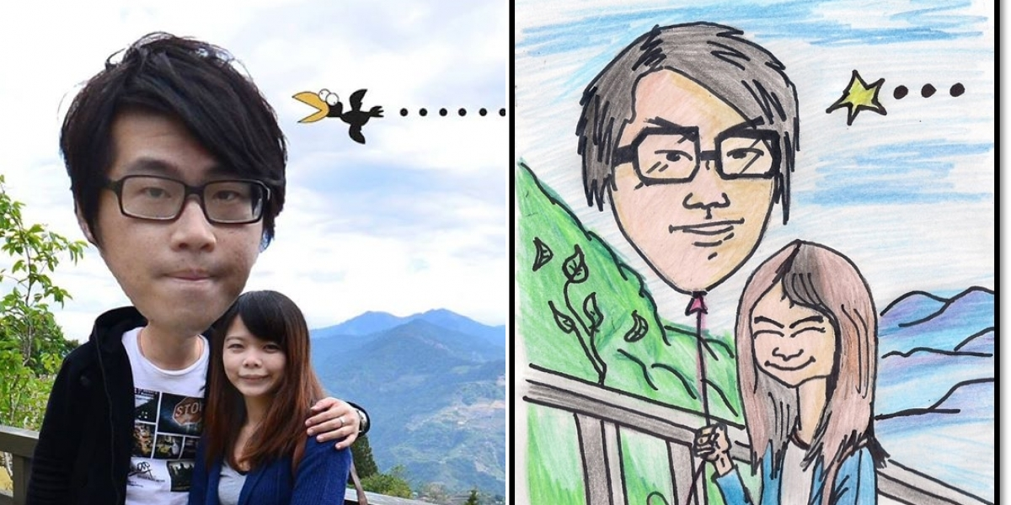The kind of contributions that seem most prevalent. These are, as described, scanned images of drawings and sketches. They vary greatly in style and aptitude of the artists. While many of these are Amateurish attempts of copying the original photographs, some are intricate and masterful renditions in watercolours and coloured pencils.

**Computer-generated illustrations[21]**

People will use this approach use programs such as Illustrator or paint to trace directly over the image. Here also, the level of skill varies, but not as much as in the previous style. 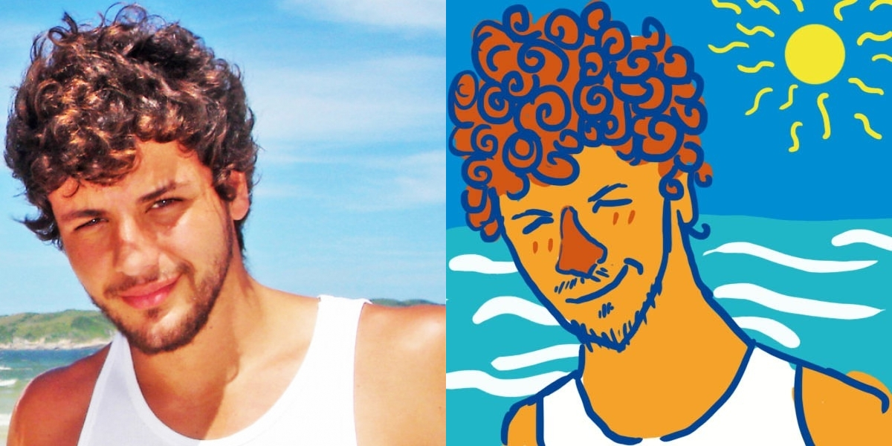

**Digitally manipulated photographs[22]**

It seems the easiest way to take the task of ‘drawing’ someone else if you do not have the time, and have basic knowledge of using photo shop or similar programs. Users will employ this tactic take the image they were given a usually put it through a series of generic visual filters that slightly alter its appearance. It may be that there is a lot of thought behind some of them, indeed some seem to have had a lot of time spent on them. However, I do not believe someone who has much ability with photo editing software is wood produced such a design. That leads me to conclude that these are represent a growing accessibility to tools which enable vernacular designed to be created. Whatever drive the participators to do this, it reflects a sincere attempt to engage with the image. 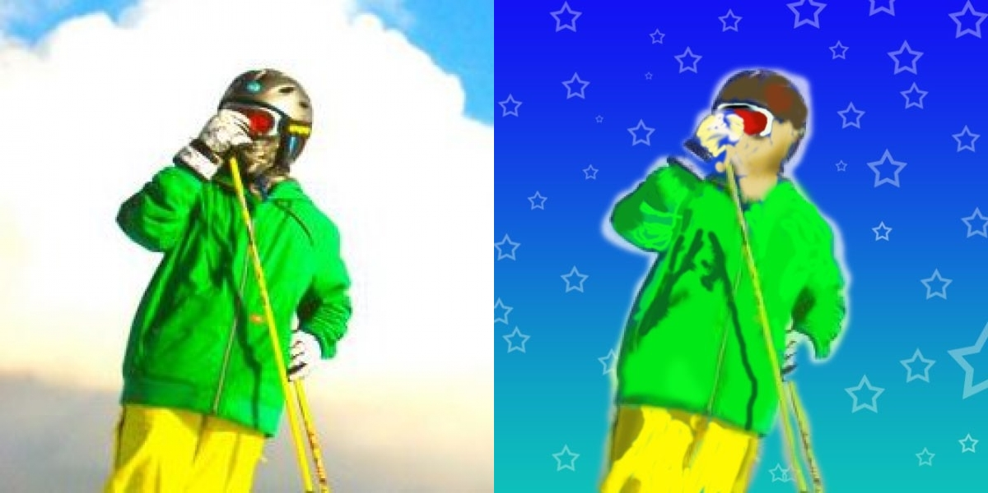

**Images which bare no visual resemblance to the original photograph**

If I was in a position to allow or condemn this type of submissions I am not sure what I would do. Images would bear no resemblance to the original photos are often black/white empty squares with nothing in them, or portrait of other people who can really have nothing to do with the original submission. But some are so funny that they make the site worth coming back for. From picture of bacon in response to a girls posing on the street[23] to an illustration of a vulture wearing a hoodie in response to a photograph of an American teen holding a rifle[24]. Some of them are clearly a mistake, yet some of them are Monty Python-esque, hilarious random stabs. It may annoy the web receives these in response to their submission, but they are as genuine as the rest and truly reflect aspects of the ‘artist’s’ persona.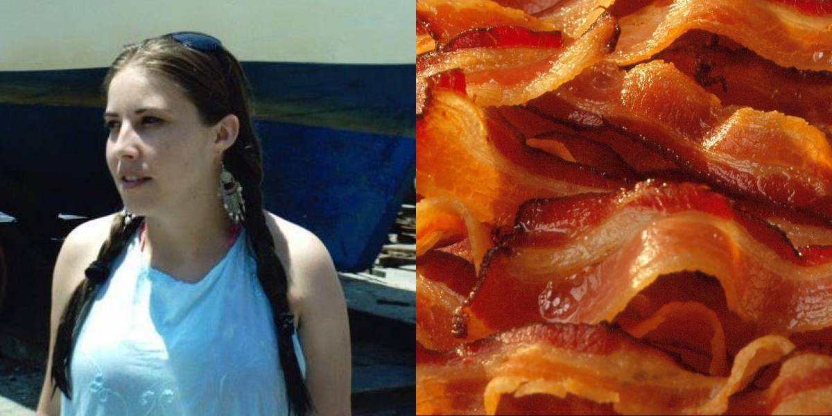 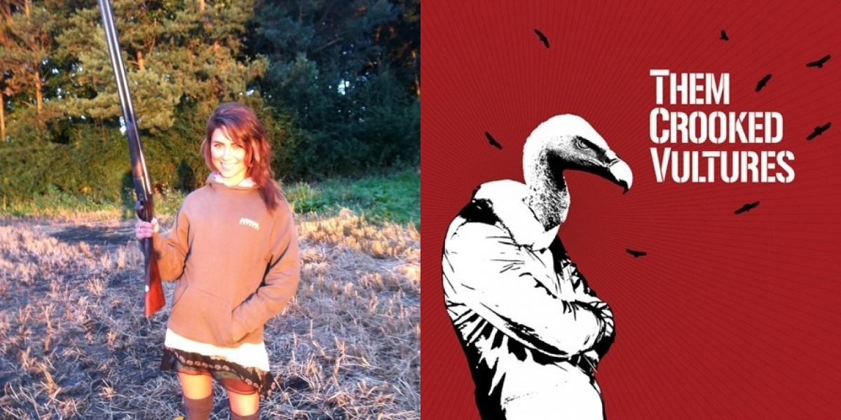

Selfless Portraits has one notable difference to the other case studies in this dissertation. It lacks any serious crowd driven moderation.

In response to the question ‘What if someone uploads a random or bogus picture rather than a legitimate drawing?[25]’ The site answers ‘When the Selfless Portraits team notices an upload like this, the image is removed from the Gallery, the person who was waiting for their portrait gets reset so they can be drawn by someone else immediately, and the person who uploaded the bogus image gets marked so they cannot be drawn by anyone, even if they try to participate again.’

So people who run the site are the moderators. Furthermore, once uploaded, may not retract or edit their submissions further.

One possible redeeming feature is the ability to sort the gallery by popularity (determined by the amount of Facebook ‘likes’). By viewing portraits in that order we can see which entries gained the crowds approval.

The only rule, which is stated in a clear way is ‘Please finish your portrait within 48 or your profile pic will NOT be eligible to be drawn.’ Once the user initiating innovative authentication this will be a reminder in the clarifications. No other rules are explicitly mentioned. It is inferred from the FAQ page that the creators are in need of further financial investment in order to develop the website further. This may explain why it’s so easy to find entries that are most likely not to satisfy whoever receives them.

Profile pictures which go through the entire Selfless Portrait process are freely available online. Basic information about the photograph’s subject is also provided freely (name and location). When you participate in the project you gain knowledge of the exact Facebook profile with which you interacted and vice versa.

The site has an inbuilt option to share work through social tools. This is significant, as it shows that at the core of the site lies the sentiment ‘look what I did!’. The website would make less sense to us if we couldn’t share it’s results with others. Why should we work hard to draw a stranger without getting any credit? And why should we give our personal photo to a stranger without something in return. This attitude may sound selfish, but in this case it individuals and helps make them into artists.

1. Alexis Ohanian: How to make a splash in social media http://on.ted.com/ikGa #TED
2. Origin http://knowyourmeme.com/memes/events/mister-splashy-pants#fn2
3. http://news.bbc.co.uk/1/hi/uk/7155255.stm
4. http://www.reddit.com/wiki/faq
5. Reddit’s user created area dedicated to hurricane Sandy related material http://www.reddit.com/r/sandy/search?q=if+anyone+needs&restrict_sr=on&sort=relevance&t=all
6. Malcolm Gladwell, 2000. The Tipping Point: How Little Things Can Make a Big Difference. 1 Edition. Little, Brown and Company.
7. http://www.urbandictionary.com/define.php?term=meme
8. <http://en.wikipedia.org/wiki/Image_macro>
9. p.22: ‘…aggregations of anything from atoms to people exhibit complex behavior that cannot be predicted by observing the component parts. Chemistry isn't just applied physics–you cannot understand all the properties of water from studying its constituent atoms in isolation. This pattern of aggregates exhibiting novel properties is true of people as well.’ Clay Shirky, . Here Comes Everybody Power of Organizing Without Organizations (Hardcover, 2008). Edition. Psnguin Pr,2008.
10. p.83-84: ‘User-generated content isn't just the output of ordinary people with access to creative tools like word processors and drawing programs; it requires access to re-creative tools as well, tools like Flickr and Wikipedia and weblogs that provide those same people with the ability to distribute their creations to others. ... User-generated content is a group phenomenon, and an amateur one. When people talk about user-generated content, they are describing the ways that users create and share media with one another, with no professionals in sight. Seen this way, the idea of user-generated content is actually not just a personal theory of creative capabilities but a social theory of media relations’. Clay Shirky, . Here Comes Everybody Power of Organizing Without Organizations (Hardcover, 2008). Edition. Psnguin Pr,2008.
11. p.298: ‘The second argument on behalf of new capabilities for groups dispenses with descriptive value and instead concentrates on political value. In this view, the current changes are good because they increase the freedom of people to say and do as they like. This argument does not suffer from the problem of incommensurability, because an increase in various forms of freedom-especially in freedom of speech, of the press, and of association-is assumed to be desirable in and

    of itself. This does not mean there will be no difficulties associated with our new capabilities-the defenders of freedom have long noted that free societies have problems peculiar to them. Instead, it assumes that the value of freedom outweighs the problems, not based on a calculation of net value but because freedom is the right thing to want for society.’ Clay Shirky, . Here Comes Everybody Power of Organizing Without Organizations (Hardcover, 2008). Edition. Psnguin Pr,2008.
12. Prologue. Nassim Nicholas Taleb. The Black Swan: The Impact of the Highly Improbable (Paperback Edition). Random House Trade, 2010
13. Part 2, INFORMATION IS BAD FOR KNOWLEDGE: ‘The more information you give someone, the more hypotheses they will formulate along the way, and the worse off they will be. They see more random noise and mistake it for information.’ Nassim Nicholas Taleb. The Black Swan: The Impact of the Highly Improbable (Paperback Edition). Random House Trade, 2010
14. http://www.thejohnnycashproject.com/
15. http://kevan.org/smaller.cgi
16. http://listen.hatnote.com/
17. P. 135 Clay Shirky, . Here Comes Everybody Power of Organizing Without Organizations (Hardcover, 2008). Edition. Psnguin Pr,2008.
18. http://selflessportraits.com/about/
19. http://ivancash.com/The-Most-Valuable-Digital-Currency
20. http://selflessportraits.com/gallery/id/40098
21. http://selflessportraits.com/gallery/id/39642
22. http://selflessportraits.com/gallery/id/40547
23. http://selflessportraits.com/gallery/id/39649
24. http://selflessportraits.com/gallery/id/40163
25. Selfless Portraits FAQ https://docs.google.com/document/d/1yJ-7Qjy9zk1JyzCH_zAuLb2u_unJzxM7GcqwXMy1Rhw/edit